Software NSR Report
User's manual

Content

Foreword 5
1 Installation and setup 6
2 Authorization and registration 8
2.1 Authorization 8
2.2 Registration 8
3 Appearance of the Program 10
3.1 Main menu of the Program 10
3.2 Screen form of the Program 12
4 Notifications: creation and sending 13
5 Sent notifications 15

Foreword
NSR Report software (hereinafter referred to as a Program) is intended for preparation and sending information covered by clauses 18-24 of the Navigation Rules in the Northern Sea Route (approved by Decree of the Government of the Russian Federation of September 18, 2020 No. 1487 "On Approval of the Navigation Rules in the Northern Sea Route").
All Program’s forms are created in accordance with the Navigation Rules in the Northern Sea Route and repeat the printed forms filled by a crew of a ship also in accordance with the Navigation Rules.

- Installation and setup
Run the NSRreport.exe file to install the Program.
The window with the selection of interface language will be provided to the user (Fig. 1).
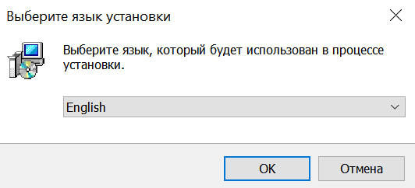

Figure 1
User should read and accept the terms of the lisence agreement to continue the installation (Fig. 2).
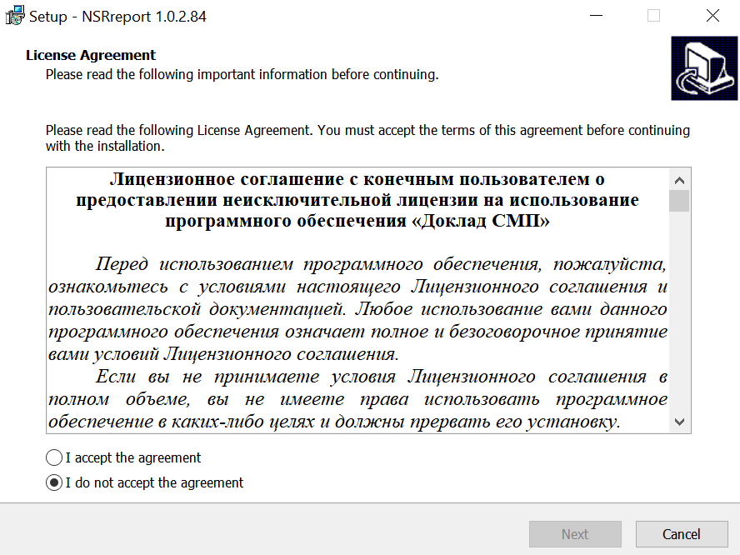
Figure 2
In the next window (Fig. 3) it will be possible to choose if it’s necessary to create a desktop shortcut for quick launch.
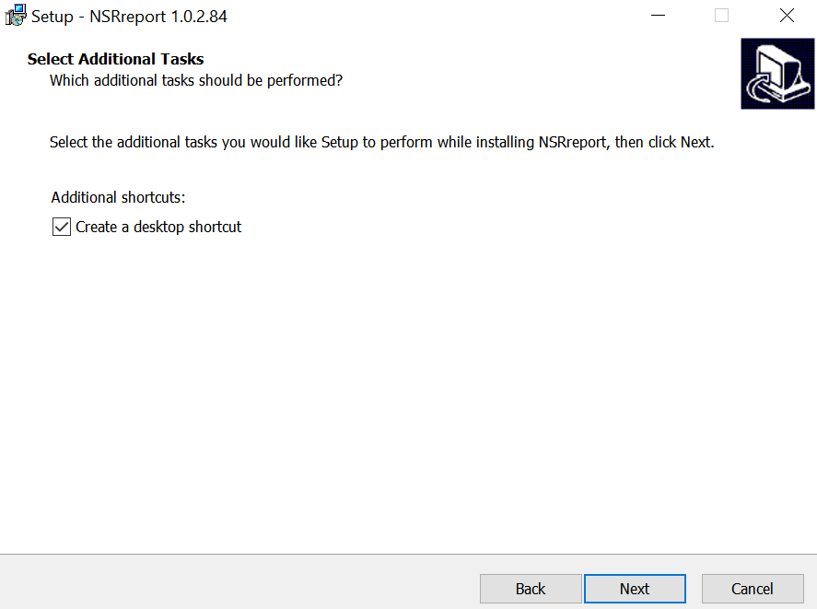
Figure 3

Setup will start after pressing buttons “Next” and “Setup” Shortcut will be created on the desktop 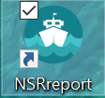.
- Authorization and registration
Authorization window will be displayed after launching the Program (Fig. 4). At first you need to select the language in the first form field.
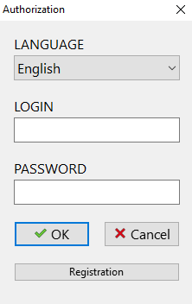
Figure 4

  - Authorization
If the user is already registered in the system, enter the login and password in the authorization window and then click on the “OK” button.

  - Registration
To register, click the "Register" button, the following form with three tabs will be shown (Fig. 5).
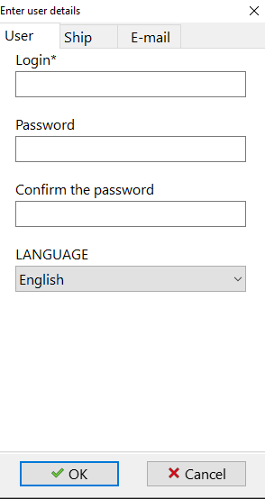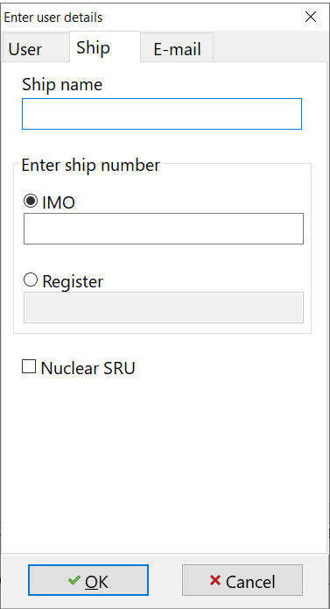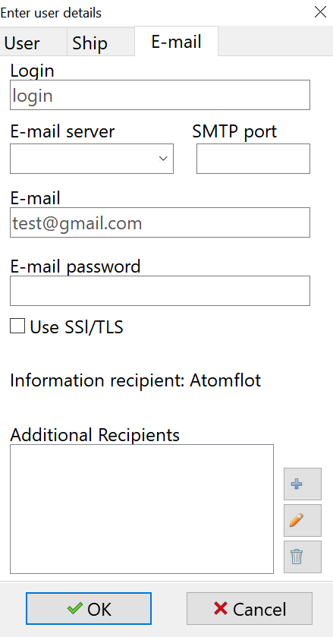
Figure 5
Enter the Username and Password to enter the Program in the "User" tab and choose the language.
In the “Ship” tab, specify the name of the ship and enter its number (IMO or the registration number).
The “E-mail” tab specifies the email parameters of the user who will send messages from the Program: login (for example, ivanov), mail server, SMTP port. Next - the email address, password for access and, if necessary, the email addresses of additional recipients of information is given. It is also possible to make a chek mark of SSL/TLS sertificate usage.The program already contains the address for sending the message to “Atomflot”. To add an additional address, click the button 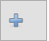; to edit an already specified address, click the button 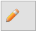; to remove an address from the recipient list, click the button 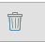.
Fields marked with * are obligatory fields.

- Appearance of the Program
The main window will be shown after authorization in the Program (Fig. 6).
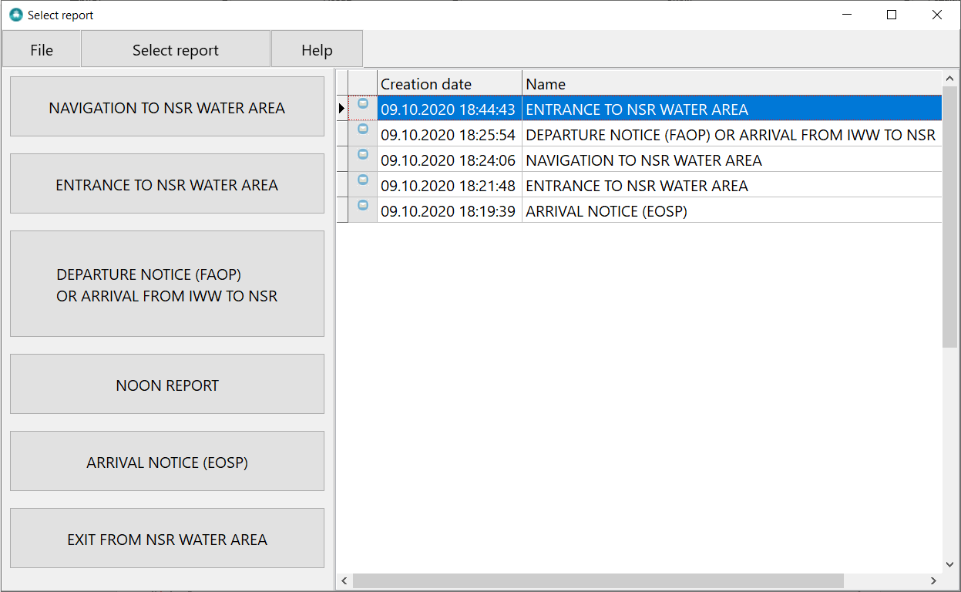
Figure 6
  - Main menu of the Program
Main menu of the Program is presented at the top of the screen form. It contains the items indicated below.
3.1.1. «File»:
- «Settings»: information about user, ship and email specified during registration in the Program.
- «Exit»: Program exit button.
3.1.2. «Select notification»:
- list of possible types of notifications that you can create and send from this Program (Fig. 7), namely:
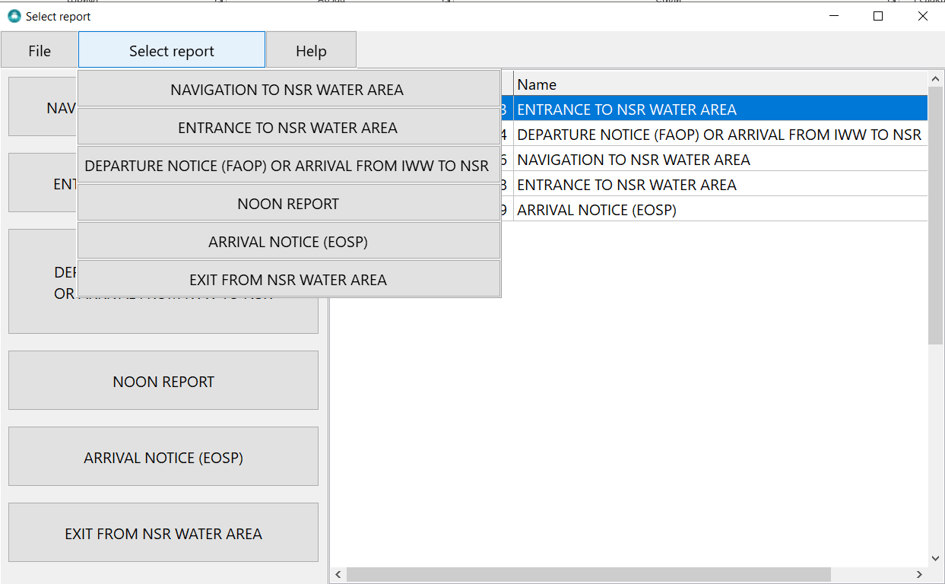
Figure 7
The list of notifications completely matches with the list presented on the left side of the screen form.
3.1.3. «Help»:
- «About the Program»: brief information about the Program and its developers with technical support email (Fig. 8).
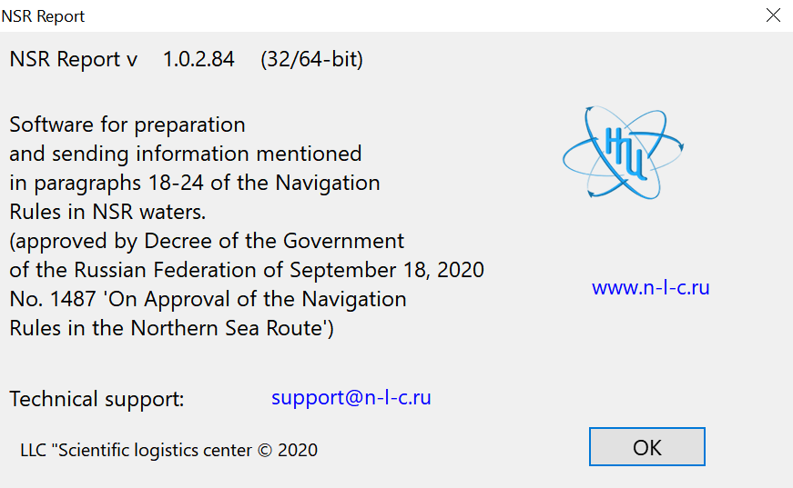
Figure 8
- «Technical support request»: window for quick creating and sending a message to the technical support service (Fig. 9).
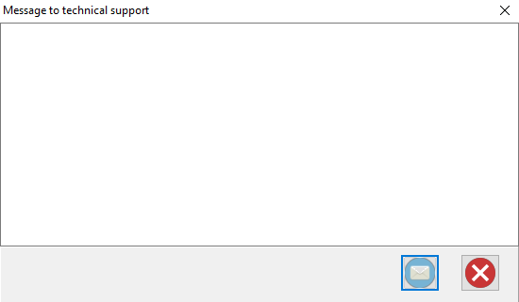
Figure 9
- “Help”: after choosing this menu option “User manual” will be provided (the document will be opened by MS Word or another software choosen by the user).
  - Screen form of the Program
There are all possible types of notifications that can be created and sent using the Program (Fig. 10) in the left part of the screen form. This list completely matches with the list in the main menu "Select Notification" section.
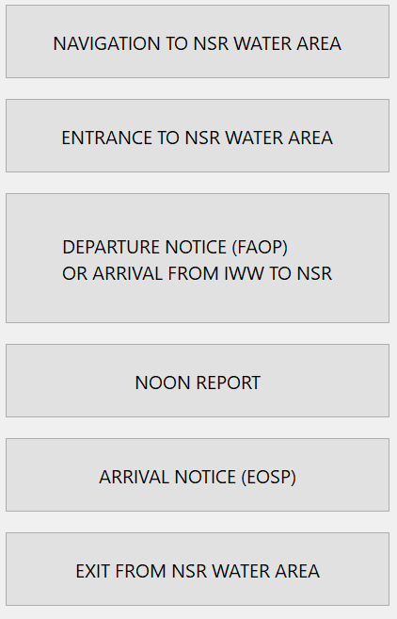
Figure 10
There are notifications created and sent earlier in the right part of the screen form, indicating their names and date of sending.
More information about the functionality of the Program is below.

- Notifications: creation and sending
To create a new notification, left-click on the desired type of notification, then the notification’s creation form will be presented.
Let's take a closer look at the process by the example of the notification “Navigation to NSR water area”
Figure 11 shows the completed notification form.
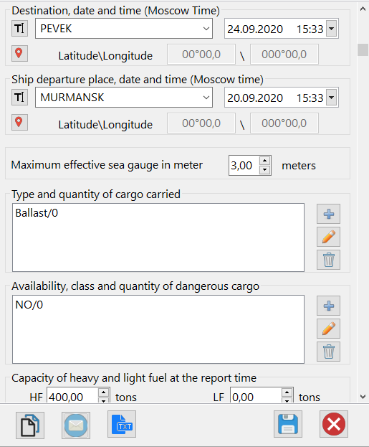
Figure 11
Form fields can be filled in manually or you can select a value from the list.
The type of transported cargo, the availability of dangerous goods and the hazard class are established by choosing values from the proposed list. To select a value from the list, press the button 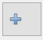. If it is necessary to edit the previously entered value or delete it, press the button 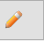 or button .
You can do the following actions with the completed notification form:
- to copy the data entered in the form to the clipboard for future use;
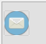 - to send notification by email;
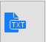 - to export the notification parameters to a text file (the *.txt file will be opened in a separate window), but all form fields must be filled;
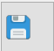 - to save entered information;
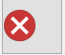 - to exit without saving. When you click on this button, dialog box will be presented (Fig. 12), you can save the entered data, not to save it or return to the form to continue working with it.
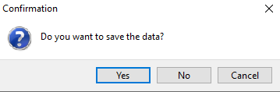
Figure 12

If the notification is saved and sent successfully, you will see a message.

Figure 13

As a result, the sent notification will appear in the list of available notifications on the right side of the screen form (Fig. 14).
Figure 14

Other types of notifications are created, filled and sent in the same way.
- Sent notifications
All notifications sent from the Program are presented on the right side of the screen form.
By double-clicking on the required notification a completed form with all parameters will be shown. By default, messages are sorted by date, from newest to oldest
Each message has an icon indicating the last action with the message on the left.
- the notification was created and copied to the clipboard;
- the notification was sent by e-mail;
- the notification was saved.

